**Stripping Components**

**Exercise 1**

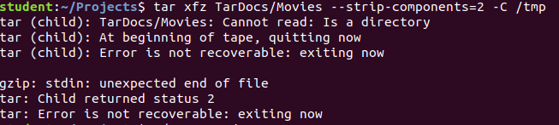

**Exercise 2**

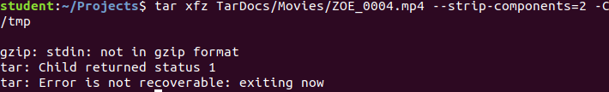

**Modifying Archives**

**Exercise 1**

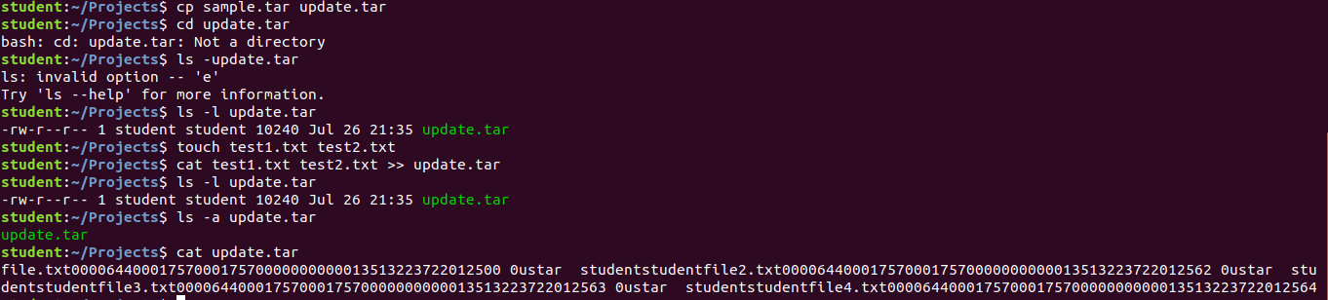

**Exercise 2**

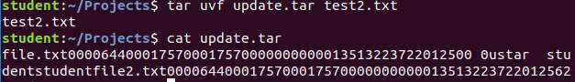

The latest copy is not in the archive

**Exercise 3**



**Incremental Backups**

**Exercise 1**

**Snapshot file**: An option that instructs *tar* to operate on an incremental archive with additional metadata stored in a standalone file.

**Backup level:** An archive containing all the files in the file system.

**Level 0 backup:** An archive with no existing file.

**Exercise 2**

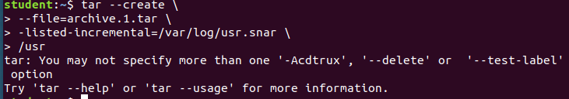

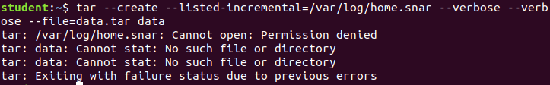





**Cron Jobs**

**\* * * * * mkdir Camara >/dev/null 2>&1**

**\*/2 */2 */2 */2 1-5 cat Camara >/dev/null 2>&1**

**1-59/2 1-23/2 1-31/2 1-11/2 0,6 echo Camara Student >/dev/null 2>&1**